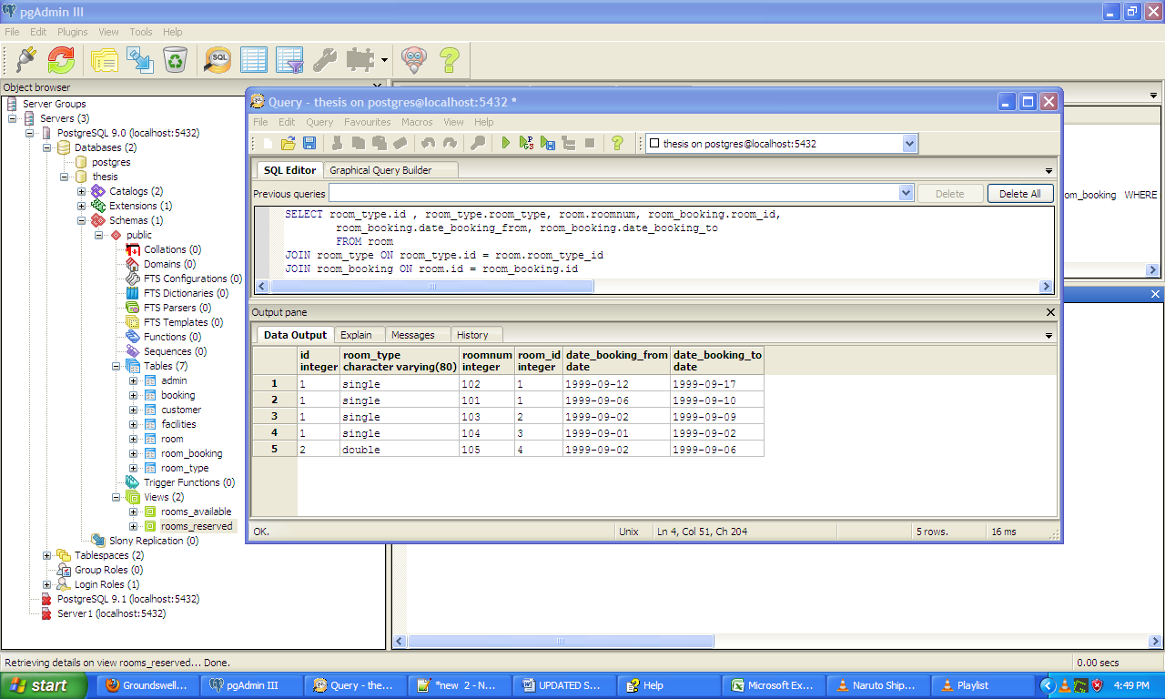

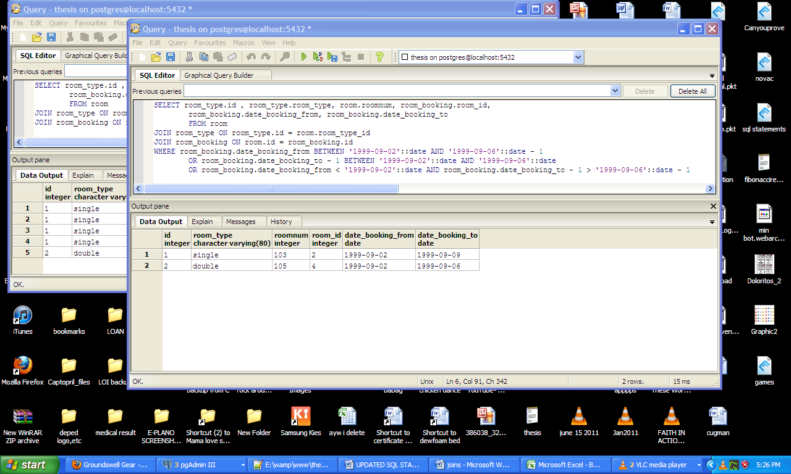**rooms_reserved between 9/2 – 9/6**

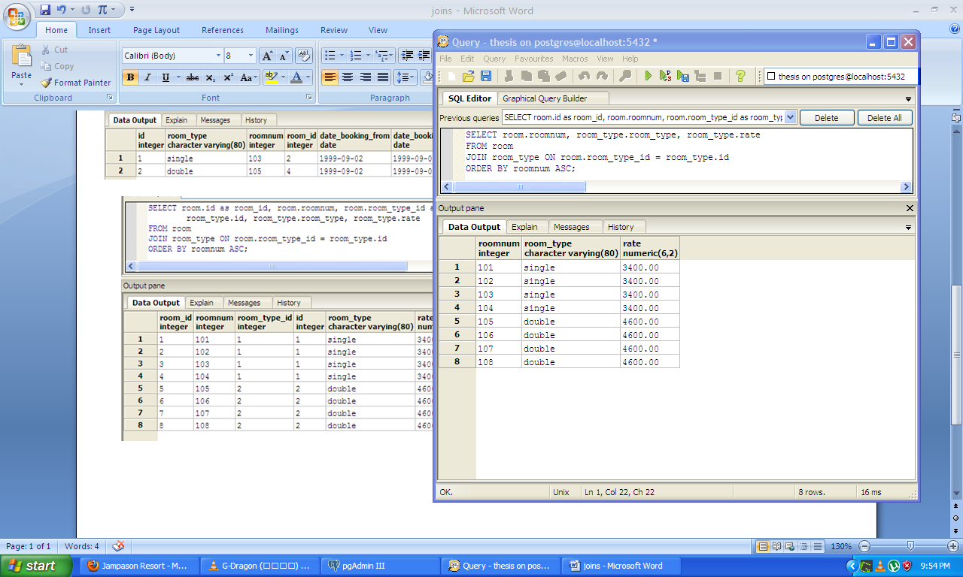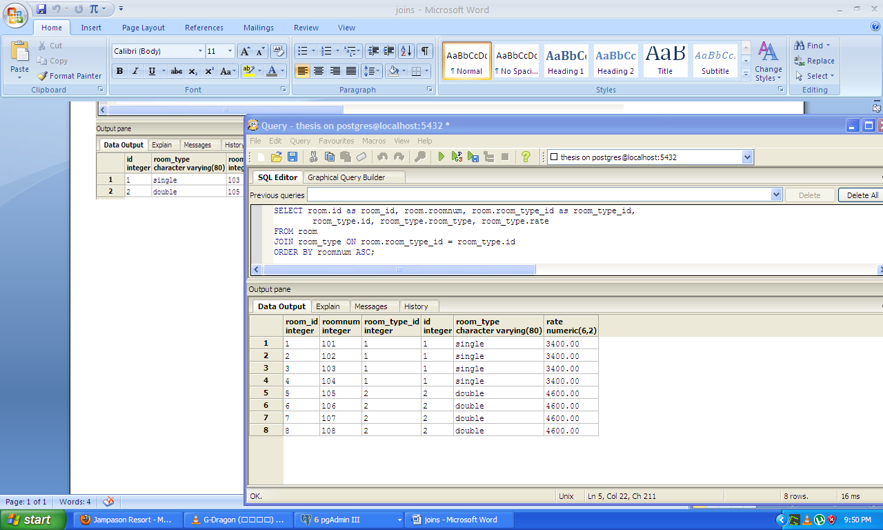**Note: --include room type(single/double) in the query together with the dates**

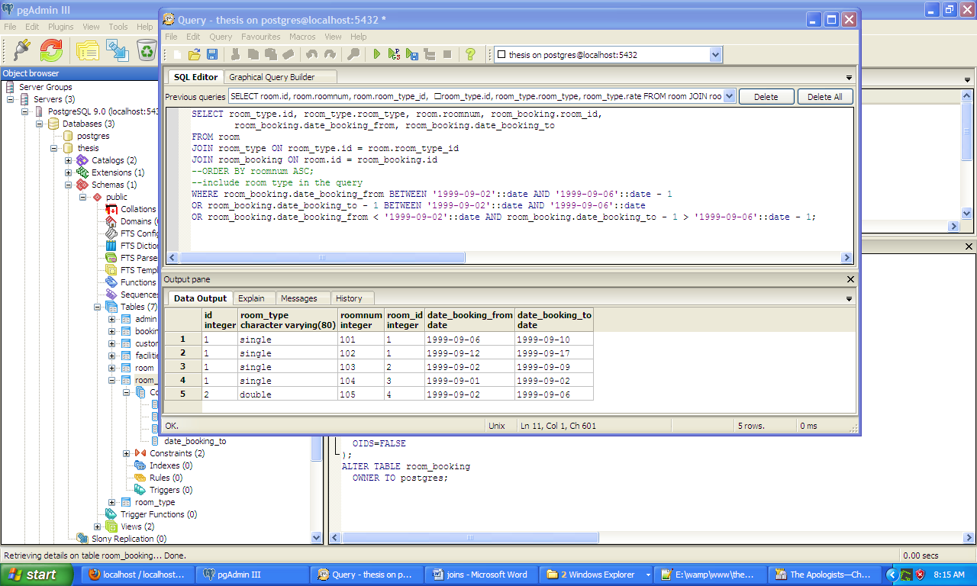

SELECT room_type.id, room_type.room_type, room.roomnum, room_booking.room_id,

room_booking.date_booking_from, room_booking.date_booking_to

FROM room

JOIN room_type ON room_type.id = room.room_type_id

JOIN room_booking ON room.id = room_booking.id

WHERE room_booking.date_booking_from BETWEEN '1999-09-02'::date AND '1999-09-06'::date - 1

AND room_type.room_type = 'single'

OR room_booking.date_booking_to - 1 BETWEEN '1999-09-02'::date AND '1999-09-06'::date

AND room_type.room_type = 'single'

OR room_booking.date_booking_from < '1999-09-02'::date AND room_booking.date_booking_to - 1 > '1999-09-06'::date - 1

AND room_type.room_type = 'single'